Mekelle University
Department of Software Engineering



Project Proposal
Local Freelance Marketplace Web Application

Submitted to:
Instructor G.Michael
Submitted by:
Nahom Mulualem
Samuel Embaye
Teame G/her
Date: October 11, 2025

Chapter 1: Introduction
1.1 Project Overview
Freelancing, as a flexible form of digital work, is increasingly becoming a valuable source of income for skilled professionals, students, and small businesses. However, the absence of a dedicated local freelance platform that supports Ethiopian has limited the potential of this growing digital workforce.
This project, titled Local Freelance Marketplace Web Application, aims to develop a web-based platform that connects clients and freelancers within Ethiopia. The system will allow clients to post projects, receive proposals, and hire freelancers, while freelancers can create profiles, browse available jobs, and submit proposals for work opportunities.
1.2 Problem Statement
Local freelancers and businesses struggle to find and manage projects securely. Most existing freelance marketplaces operate internationally, limiting accessibility for Ethiopian users. As a result, many local freelancers and clients resort to informal social media groups, which lack transparency, reliability, and secure payment tracking.
1.3 Project Scope
In Scope:
The following functionalities will be included in the current project phase:
- Full Role-Based Access Control: Secure authentication and authorization system allowing clients and freelancers to perform distinct role-specific actions within the platform.
- Messaging System: A built-in text-based communication module enabling real-time discussion and coordination between freelancers and clients.
- Job Posting and Browsing Feeds: A structured job board where clients can post available projects and freelancers can browse listings based on category, skill, or location.
- Proposal Submission: A system that allows freelancers to submit proposals, including cover letters and supporting files, in response to client postings.
Out of Scope:
To maintain focus and ensure timely delivery, certain advanced features will not be included in this project phase:
- Mobile Application: The system will be developed as a web application only, optimized for both desktop and mobile browsers.

Chapter 2: Objectives and Goals
2.1 Project Objectives
The main objective of the Local Freelance Marketplace Web Application is to design and develop a secure, responsive, and user-friendly platform that connects clients and freelancers. The system aims to facilitate efficient collaboration by enabling clients to post jobs and freelancers to apply for suitable projects through an intuitive web interface.
Specifically, the project seeks to:
- Develop a full-stack web application using Next.js, Node.js, and PostgreSQL.
- Implement secure authentication using JWT.
- Allow clients to post and manage job listings effectively.
- Enable freelancers to browse, filter, and apply for jobs.
- Integrate a simple messaging feature for client–freelancer communication.
2.2 Key Deliverables
The project’s major deliverables include:
- System Design Documentation: A clear outline of system requirements, use cases, and architectural design.
- Prototype: Wireframes illustrating user interface flow and main components.
- Functional Web App: A working version of the web platform with authentication, job posting, proposal submission, and messaging features.
- Testing and Documentation: Comprehensive testing reports and a final project report summarizing implementation, results, and conclusions.

Chapter 3: Requirements Analysis
3.1 Functional Requirements
Functional requirements define the essential operations and behaviors the system must provide to meet user needs.
ID | Requirement | Description | Priority
FR-01 | User Registration & Login | Secure registration and login for clients and freelancers using email and JWT authentication. | High
FR-02 | Profile Management | Users can create and update profiles with skills, experience, and portfolio information. | High
FR-03 | Job Posting & Management | Clients can create, edit, and manage job listings with details such as title, category, and deadline. | High
FR-04 | Job Browsing & Search | Freelancers can browse and filter available jobs by category, location, and relevant skills. | High
FR-05 | Proposal Submission | Freelancers can submit proposals including cover letters, bid amounts, and optional attachments. | High
FR-06 | Messaging System | Enables real-time text-based communication between clients and freelancers. | Medium
FR-07 | Matching & Recommendation | Suggests relevant jobs to freelancers based on their profiles, skills, and past activity. | Medium
FR-08 | Contract Management | Allows clients to hire freelancers and establish basic digital contracts for work delivery. | Medium
FR-09 | Payment Simulation | Conceptual escrow-style payment representation for demo purposes (no real transactions). | Low

3.2 Non-Functional Requirements
Non-functional requirements ensure that the system performs efficiently, securely, and reliably under different conditions.
ID | Requirement | Description | Priority
NFR-01 | Performance | The system should handle multiple concurrent users with minimal latency and fast response times. | High
NFR-02 | Usability | The interface should be intuitive, user-friendly, and responsive across both desktop and mobile devices. | High
NFR-03 | Security | Ensure role-based access control, input validation, HTTPS encryption, and JWT-based authentication. | High
NFR-04 | Reliability | The system should operate continuously with minimal downtime or unexpected failures. | High
NFR-05 | Scalability | The architecture should allow future expansion for features such as ratings and payment gateways. | High
NFR-06 | Maintainability | Codebase should be modular, well-documented, and structured for easy debugging and updates. | High

Chapter 4: System Design and Architecture
4.1 System Architecture Overview
The Local Freelance Marketplace Web Application is designed using a three-tier architecture consisting of the presentation layer, application layer, and data layer. This layered approach ensures scalability, maintainability, and clear separation of responsibilities.
- Presentation Layer (Frontend):
  - Built using modern frontend frameworks such as Next.js to ensure an interactive, responsive, and user-friendly interface.
  - Provides separate dashboards for freelancers and clients, allowing easy navigation between project listings, proposals, and messages.
  - Implements responsive design principles for optimal viewing on both desktop and mobile devices.
- Application Layer (Backend):
  - Developed using Node.js and Express.js to handle core business logic, authentication, and API requests.
  - Ensures secure communication between the frontend and database using RESTful APIs.
  - Manages job postings, user interactions, and message exchanges efficiently through modular service components.
- Data Layer (Database):
  - PostgreSQL is used as the main relational database to store structured data, including user profiles, job details, and proposals.
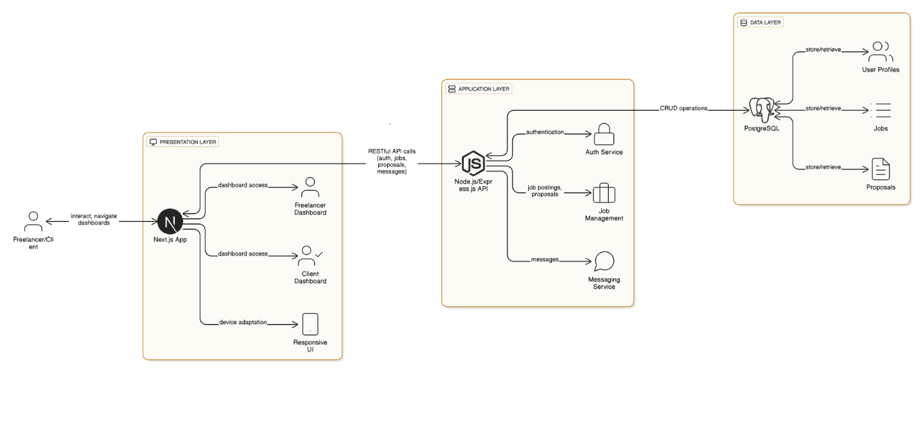

4.2 Data Flow and System Interaction
- A freelancer or client interacts with the web interface to register or log in.
- The frontend sends the request to the backend API for validation and authentication.
- The backend processes the request and retrieves or stores information in PostgreSQL.
- Data such as job listings, profiles, and proposals are displayed dynamically on the frontend.

Chapter 5: Methodology
5.1 Development Approach
The project will be developed using the Agile methodology, emphasizing iterative progress, collaboration, and adaptability. Development will occur in short sprints, each focused on specific modules such as authentication, job posting, or messaging. Regular reviews will ensure continuous improvement and alignment with objectives.
5.2 Tools and Technologies
- Version Control: Git and GitHub for collaborative coding and version tracking.
- Project Management: Trello for organizing tasks, tracking sprint progress, and assigning responsibilities.
- Backend Testing: Postman for API validation and performance testing.
- Communication: WhatsApp for quick coordination and team updates.
5.3 Implementation Strategy
Development will begin with requirement analysis and system design, followed by backend and frontend implementation. Continuous integration and testing will be performed after each sprint to ensure code quality and functionality. Feedback will guide refinements before final deployment and documentation.

Chapter 6: Timeline and Milestones
The project will be completed over an estimated 10-week period, progressing through sequential yet overlapping phases to ensure efficiency and quality.
Weeks 1–2: Requirement Analysis and Design
Gather functional and non-functional requirements, design system architecture, and define the database schema.
Weeks 3–5: Backend Development
Develop RESTful APIs using Node.js and Express, integrate PostgreSQL through Prisma ORM, and implement authentication and core logic.
Weeks 6–8: Frontend Development
Build responsive interfaces using Next.js and TailwindCSS, connect frontend with backend APIs, and ensure role-based user experiences.
Week 9: Testing and Integration
Conduct unit, integration, and usability tests, resolve detected issues, and refine system performance.
Week 10: Documentation and Review
Prepare final documentation, summarize project outcomes, and conduct review for presentation readiness.
Key Milestones:
- End of Week 2: Requirement and design completion.
- End of Week 5: Backend fully functional.
- End of Week 8: Integrated web interface.
- End of Week 9: Testing completed.
- End of Week 10: Final documentation delivered.

Chapter 7: Risk Analysis and Mitigation
7.1 Potential Risks
- Technical Risks:
- Challenges in integrating backend APIs.
- Issues in managing database relationships.
- Difficulties in implementing real-time messaging features.
- Time Management Risks:
- Possible delays due to unforeseen technical issues.
- Inaccurate time estimation for specific tasks.
- Scope Risks:
- Addition of new or unplanned features during development (scope creep).
- Ambiguities in project requirements.
7.2 Mitigation Strategies
- For Technical Risks:
- Allocate extra time for research and problem-solving.
- Conduct regular code reviews and testing.
- For Time Management Risks:
- Use Trello for task tracking and progress monitoring.
- Hold weekly meetings to review progress and reassign tasks if needed.
- For Scope Risks:
- Clearly define and document project requirements.
- Evaluate all change requests before approval to prevent scope creep.

Chapter 8: Conclusion and References
Conclusion
The Local Freelance Marketplace Web Application aims to create a reliable digital platform that connects freelancers and clients within the Ethiopian market. By integrating modern technologies such as Next.js, Node.js, and PostgreSQL, the system will deliver a secure, efficient, and user-friendly experience for both parties. The project not only addresses a growing demand for localized freelance opportunities but also enhances the team’s practical skills in full-stack web development, project management, and system deployment. Ultimately, the platform aspires to contribute to the advancement of local digital employment solutions through a scalable and maintainable system.
References
- Next.js Documentation – https://nextjs.org/docs
- Node.js Documentation – https://nodejs.org/en/docs
- Express.js Documentation – https://expressjs.com
- PostgreSQL Documentation – https://www.postgresql.org/docs
- Prisma ORM Documentation – https://www.prisma.io/docs
- TailwindCSS Documentation – https://tailwindcss.com/docs

